ENTREPRENURE RESEARCH PROJECT

Your internet research project is to identify 4 entrepreneurs, of your choice,
to discover their traits and characteristics. (2 must be Canadian)

The Research must include;

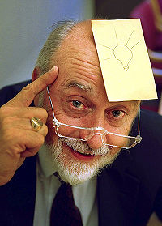
- Read about the entrepreneur, write a personal profile and summarize their venture. ( Value 40%). A biographical sketch. This does not have to be long.

- The main purpose of this write-up is to study their entrepreneurial characteristics. Refer to the text page 28 and your notes and focus on his/her/their main characteristics that made them successful. ( Value 60%)

- I want to read in the second half of each report in your own words, your reflections on the entrepreneur’s traits and characteristics.

- One page for each Entrepreneur, your page may include 1- 2 max small thumbnail pictures. Single spaced, 12 point font, titles and your name at the top. Footnote ALL internet sources in a footnote at the bottom. Absolutely no cut and paste plagiarism of information. I would rather see less material in your own words, than read info copied from a site. (this is a ZERO, LHHS policy)

_____Title_______  Name of Entrep_________  Your Name__________________  _A_______________________________________________________________________________________________________________________________________________________________________________________________________________________________________________________________________________________________B_____________________________________________________________________________________________________________________________________________________________________________________________________________________________________________________________________________________________________________________________________________________________ ___________________________________________________________________________________________________________ | 