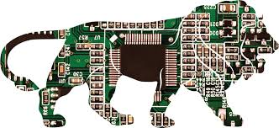
120 Micro Electronics
Assignment #1

Name_________________________________
- Read pages in opening part of the Manual through to page 11
- Identify the 18 Components from the “Parts Bin” Name, Drawing, Symbol. Draw the component 2D figures, Go back to the Components page and draw each Symbol.
Component Description | Symbol | Pic or Drawing
1 Capacitor
2 Diode
3 Zener Diode
4 LED
5 Resistor
6 Potentiometer
7 Push Button
8 SPST Switch
9 Relay
10 Amplifier
11 NPN Transistor
12 Photo Transistor
13 SCR
14 Regulator
15 FET
16 Speaker
17 Transformer
18 4 Logic Gates

2. Discovering how the Bread Board is laid out. Draw the lines to show the paths of continuity.
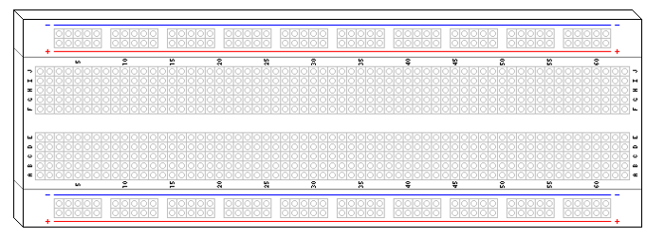
- Draw and Identify the POLARITY of the following;
- LED

B. Capacitor

C. Diode

- Read the following resistors
YELLOW - VIOLET - BROWN - GOLD is
BROWN - BLACK - RED - GOLD is
ORANGE - ORANGE - RED - GOLD is
BROWN - BLACK - ORANGE - GOLD is
_______________________________33,000 Ω (or 33 kΩ) with 5% tolerance
________________________________100,000 Ω (or 100 kΩ) with 5% tolerance
________________________________1,000,000 Ω (or 1 MΩ) with 5% tolerance

