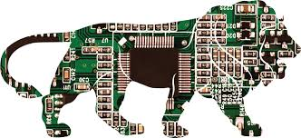
120 Micro Electronics
Assignment 3
Name_________________________
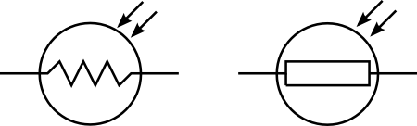
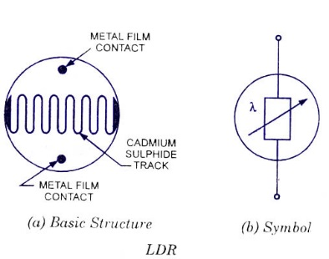
Define the use of the Light dependent resistors

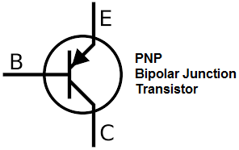
Define the use of the Photo Transistor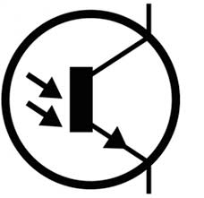

Define the use of the MOSFET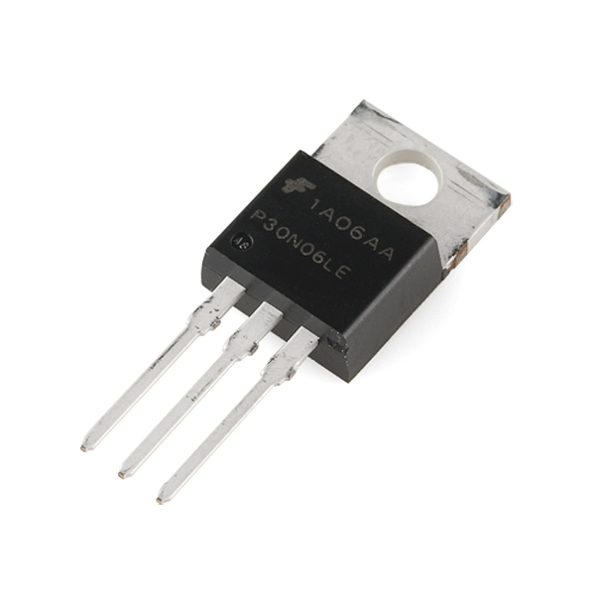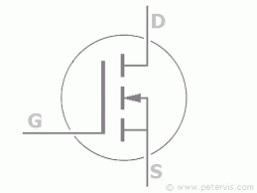
The MOSFET (Metal Oxide Semiconductor Field Effect Transistor) transistor is a semiconductor device which is widely used for switching and amplifying electronic signals in the electronic devices. The MOSFET is a core of integrated circuit and it can be designed and fabricated in a single chip because of these very small sizes. The MOSFET is a four terminal device with source(S), gate (G), drain (D) and body (B) terminals. The body of the MOSFET is frequently connected to the source terminal so making it a three terminal device like field effect transistor. The MOSFET is very far the most common transistor and can be used in both analog and digital circuits.
How many MOSFETs have been built since 1947-2018?____________________________

