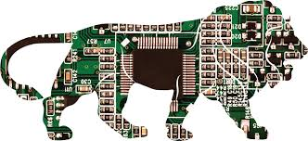
Micro Electronics 120
Exit Project 8 -Knight Rider
___________________________________NAME____________
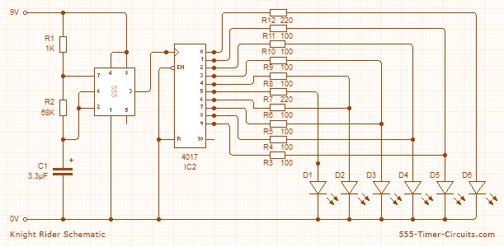
Parts  1x NE555 Bipolar Timer  6x LED (Red)  8x 100 Resistor (1/4W)  2x 220 Resistor (1/4W)  1x 1K Resistor (1/4W) | 1x 68K Resistor (1/4W)  1x 3.3�F Electrolytic Capacitor (16V)  1x 4017 Decoded Decade Counter  1x 9V Voltage battery

ANSWER THE FOLLOWING
- Draw the circuit. Label all the components.

- Explain in your own words how this circuit works.

- What does the 555 Timer do?

- What does the 4017 Counter do?

- What job does the capacitor do in the circuit?

KNIGHT RIDER CIRCUIT
This circuit mimics the lights in knight rider's car. They flash one at a time chasing each other.
Overview
In the Knight Rider circuit, the 555 is wired as an oscillator (Astable mode). The output of the 555 is directly connected to the input of a 4017 decade counter.
The input of the 4017 counter is called the CLOCK line. The 10 outputs Q₀ to Q₉ become active, one at a time, on the rising edge of the waveform from the 555. Each output can deliver about 20mA but a LED should not be connected to the output without a current-limiting resistor (100R or 220R).
Using six 3mm LEDs, the display can be placed in the front of a model car to give a very realistic effect. The same outputs can be taken to driver transistors to produce a larger version of the display.
This circuit consumes 22mA while only delivering 7mA to each LED. The outputs are “fighting“ each other via the 100R resistors (except outputs Q0 and Q5).
Video
The video can be found on the teachers share drive- Intro To Electronics – Exit Project 5
Or look it up- http://www.555-timer-circuits.com/knight-rider.html

