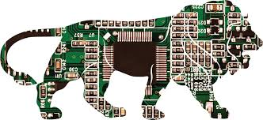
120 Micro Electronics
Logic Gates Assignment
Name_________________________________
Go To http://www.ee.surrey.ac.uk/Projects/CAL/digital-logic/gatesfunc/#introduction
- What are the input voltages of the logic gates?
- Are there time delays between input and output?
- Do gates need a voltage supply?
- Identify each Gate Symbol, write in each name (or letter acronym) and Complete the Following Truth Tables

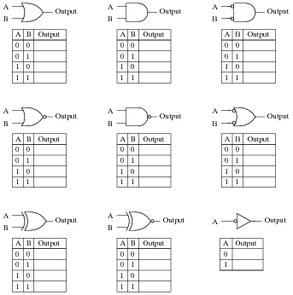

- Read the material remaining and Take the quiz at the end. You can check you answers at the end.

