120 Micro Electronics
Lab - 555 Timer tester

Name_________________________________

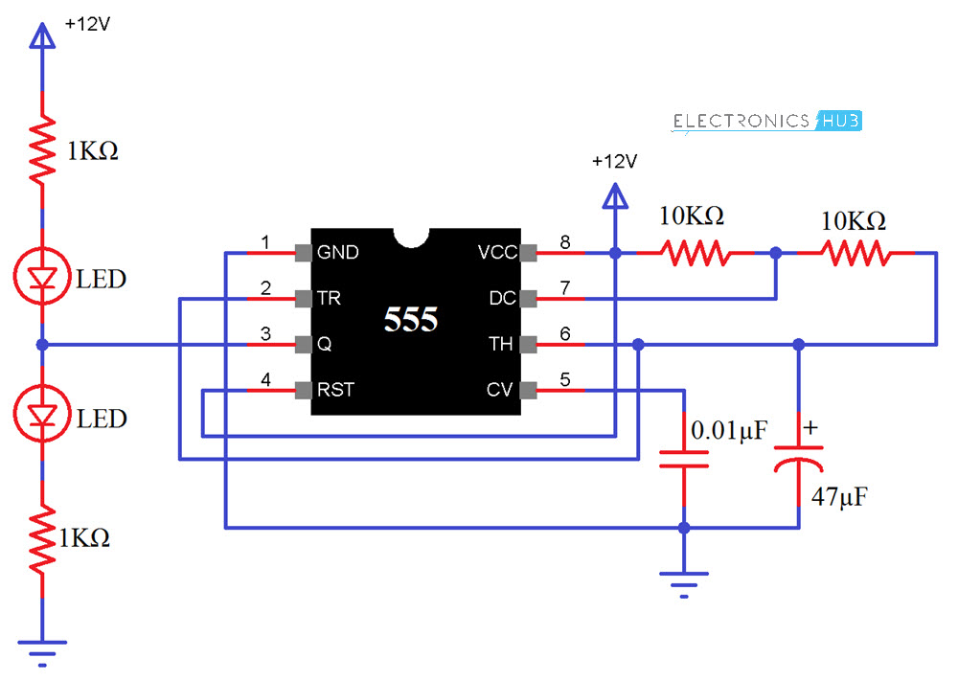

Working of 555 Timer IC Tester Circuit
In this circuit, I have used the 555 IC as an Astable multivibrator and when power is provided to circuit, the LEDs will start blinking, which means that the IC is working. The blinking rate of LEDs can be changed by increasing or decreasing the values of resistor R1 and R2 and capacitor C1.
You can calculate the time duration with the help of formulae given below.
ON Time (HIGH) in Seconds = 0.693 * (R1 + R2) * C1
OFF Time (LOW) in Seconds = 0.693 * R2 * C1
Total Time Period in Seconds = 0.693 * (R1 +2R2)*C1
Frequency = 1.44 / ((R1 + 2R2) * C1)

