Lab #4 The NAND Gate
Name:_____________________
Using the schematic below hook up the circuit using any one of the NAND gates on the IC. Remember that you must power the chip in order for it to work. Have your teacher sign the circuit indicating the circuit works.
Verify and complete the truth table.
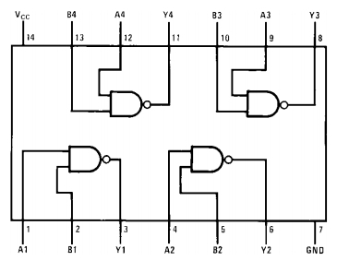
Instructor Signature:____________________________
Truth Table
A | B | Y

Problem:
- Can a NAND Gate be used to make a NOT Gate? If so draw the schematic and develop the truth table.
- Show how an AND Gate can be made from 2 NAND gates. Hook up the circuit and complete the truth table.

