Lab #6 The NOR Gate
Name:_____________________
Using the schematic below hook up the circuit using any one of the NOR gates on the IC. Remember that you must power the chip in order for it to work. Have your teacher sign the circuit indicating the circuit works. 7402 IC
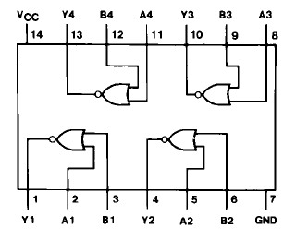
Verify and complete the truth table.

Instructor Signature:____________________________
Truth Table
A | B | Y

Problem
- Construct a NOT Gate using a NOR Gate. Develop and verify the truth table.
- How would you construct an AND Gate using only NOR Gates? Develop and verify the truth table.

Instructor Signature:____________________________

