Entrepreneurship 110

Chapter 9- Operations /Management and Supplies /Resources Notes

1. 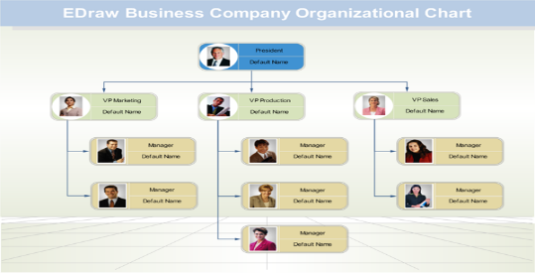Fixed Cost-
2. Variable Costs-
3. Material Resources-
4. Technological Resources-
5. Financial Resources-
6. Human Resources-
7. What is an operation Strategy? ( Main Parts)
8. What questions does your operation strategy need to answer?
9. What are the 4 legal forms or business? Give an advantage and disadvantage for each.
10. S.P
11. P
12. G
13. L
14. Corp
15. F
16. Name the 4 leadership styles and describe in one sentence each style

a.

b.

c.

d.

SUMMER CAR WASH and DETAILING Venture at REGENT MALL

C:\Users\Todd.Robinson\AppData\Local\Microsoft\Windows\Temporary Internet Files\Content.IE5\Z7UOXTJN\MC900280771[1].wmf

As lead and sole proprietor on a car wash venture, how would you organize this 3 month summer venture?

Design a flow chart

**Consider;**

Day to Day operations

Week to Week and monthly operations

Number of staff, roles for each,

What leadership style will you choose?

Show your structure, daily weekly