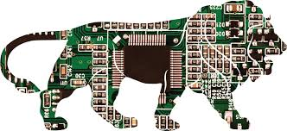
Micro Electronics 120
Lessons 1-6 Test - Review
____________________________________NAME____________
- Page 1-24
- Study 18 basic components from xvii
- Know the Breadboard routing, how to attach safety diode
- Draw basic schematic diagrams for cell, battery, diode, resistor, LED, Incandescent Bulb, pot, motor, LDR
- Know resistor Codes, read resistors,
- Know scale of DMM

