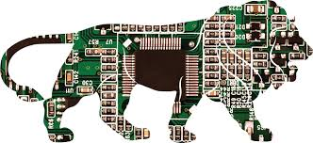
120 Micro Electronics
Test 3
Name_________________________________
REVIEW
Lab 9 and 10
- Know 4 ways to identify the NPN and PNP Transistor
Number, Pin out, Symbol, function (how they operate)- draw them-
- Effects of a Capacitor on/in a circuit-
Lab 11
- Know Photo Transistor, symbol, function of the gate, do phototransistors act like NPN or PNPs? Know what is an LDR- the symbol and how they work back on Pg 21 they conduct electron flow.
- Here is a question- LDRs response time is measured in Ohms per millisecond. The phototransistor is measured in microseconds, that 1,000 times faster than a LDR can you explain why the difference in response time? Pg 40
Lab 13
- What does SCR stand for, symbol, and leg pin out, what is meant by “latching” or “trapdoor” abilities. How is an SCr a transistor? What is the difference between a Triac and a Diac?
Lab 14
- The voltage regulator “regulates” output- why and how is this necessary/done?
- Describe unregulated voltage and “stable” or Regulated voltage and how each occur in a circuit.
- Describe what the capacitor helps do in the circuit.
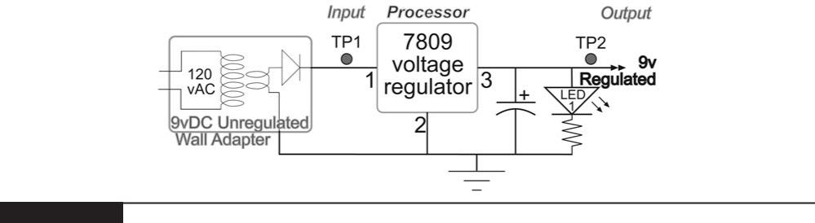

Binary to Decimal and Back

Bit number | Bit 8 | Bit 7 | Bit 6 | Bit 5 | Bit 4 | Bit 3 | Bit 2 | Bit 1
Value | 128 | 64 | 32 | 16 | 8 | 4 | 2 | 1

- Translate the following 8-bit binary codes to the decimal equivalent.

Binary Decimal

10101100

01100110

10010011

00110001

- Looking at the IC from the top, the reference notch should be to the left or if in a breadboard- to the top . Then, pin 1 is on the bottom left. The numbering starts there and moves counterclockwise. Usually 1-14 with 14 being Voltage in and 7 Ground.

Comparing the Gates

NOT |  |  | AND |  |  | OR |  |  | NAND |  |  | NOR
In | Out | In A | In B | Out | In A | In B | Out | In A | In B | Out | In A | In B | Out
 | Put |  | Put |  | Put |  | Put |  | Put
High | Low | High | High | High | High | High | High | High | High | Low | High | High | Low
Low | High | High | Low | Low | High | Low | High | High | Low | High | High | Low | Low
 |  | Low | High | Low | Low | High | High | Low | High | High | Low | High | Low
 |  | Low | Low | Low | Low | Low | Low | Low | Low | High | Low | Low | High

